APPLECROSS SENIOR HIGH SCHOOL

YEAR 11 HUMAN BIOLOGICAL SCIENCES

GENETICS TEST

NAME:_________________________________ SCORE:______/ 25

Hints: Write your answers on this question paper in biro. One mark will be deducted for answers in pencil. Provide a key to symbols for every question requiring working. Label fully each step in your working out. Unlabelled working out will not gain marks.

- The gene for ability to taste the chemical PTC is dominant to the gene for inability to taste PTC. It is an autosomal trait. A woman who can taste PTC (although her father cannot taste PTC) marries a man who can taste PTC (although his mother cannot taste PTC). What phenotypic ratios would be expected in their offspring?

Key:

Working Out:

Answer: The phenotypic ratios expected in the offspring would be:

_________________________________________________________________ [5 marks]
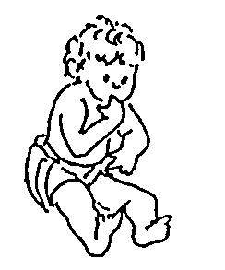
2. Huntington’s disease is a disorder of the nervous system in which the victim gradually loses control over his/her body. The symptoms don’t appear until mid-life. It causes premature death.
Huntington’s disease is caused by an autosomal dominant gene. A normal male marries a female who is heterozygous for Huntington’s disease. What is the probability that they will produce a child who will develop Huntington’s disease in later life?

Key:

Working:

Probability of a child with Huntington’s disease _______________________________ [5 marks]

Terminology (Spelling will be penalised in questions 3-7.)

3. A pair of alleles which are the same is termed __________________________

4. A pair of chromosomes which contain genes controlling the same traits is called

___________________________

5. An inheritance pattern in which a pair of different alleles both partially show their effect, is called
___________________________

6. The Human Genome Project determined the location of many human genes.
The location of a particular gene is called its
___________________________

7. The display of the chromosomes from one cell, showing the chromosomes arranged in pairs, is called a
___________________________

[5 marks]
8. Haemophilia is a recessive, X-linked trait. A haemophiliac male marries a female whose blood clots normally, and who has no family history of haemophilia. She is pregnant and an ultrasound shows that the foetus is male. What is the chance of this child being a haemophiliac?

Key:

Working Out:

Possible Phenotypes of Offspring: _____________________________________________
[5 marks]

9. Pedigree of Duchenne Muscular Dystrophy.

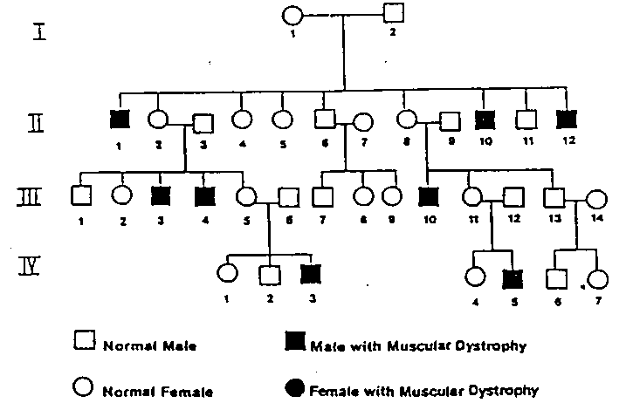

(i) Choose from the following list, all the words which describe the mode of inheritance of Duchenne Muscular Dystrophy : dominant; recessive; autosomal; X-linked.

Answer:__________________________________________________________ [2 marks]

- What are the genotypes of the following individuals shown in the above pedigree? Provide a key to your symbols.

Key:

Person II 1 ________________________

Person III 5 ________________________

[3 marks]

